JJPRS - Payroll System

User Manual

Version 2.0



**By:**

**Jarrett Gonzalez**

**Jason Nieto**

**Patrick Medida**

**Ryan Ng**

**Serhan Akturk**

Table of Contents

1. Introduction 3
2. Process Overview 4
3. Getting Started 5
   1. Login Screen 5
   2. Main Menu 7
   3. Payroll Info 8
   4. Profile Info 9
   5. Time Management 10
   6. Benefits 11
   7. Search 12
   8. Print Check 14
   9. Modify Employees (Admin) 15
   10. Logout 17
4. Troubleshooting & Support 18
5. Introduction­­­­­­­­­­­­­

The JJPRS payroll system is intended for companies who want to integrate a payroll system into their company. It will help the company maintain, update, and organize their user’s salaries, tax deductions, hours, and many more. This user manual will help the user become familiar with all the functions of the JJPRS payroll system, how to navigate through the application from beginning to end, and how to troubleshoot any problems the user encounters.

1. Process Overview

The key features and overview of the Payroll System:

* Users can log into their accounts as an Employee or HR.
* The user’s information will be safely stored within customer’s database.
* Once a user is logged in, they can click on various functions for their needs.
* Some of these functions range from viewing their personal information, to viewing their net pay, or printing out a check.
* The user will also have an option to return to a previous page.
* Once the user is done, they can simply logout.

1. Getting Started

Before starting the user will need a working computer, access to the internet, and the user’s username and password credentials that will be provided by the user’s company.

The next part will be a step-by-step explanation of how to use the product:

Step 1: Login Screen

Users can login as an employee or an admin. If logging as an employee simply enter your employee login username and password.

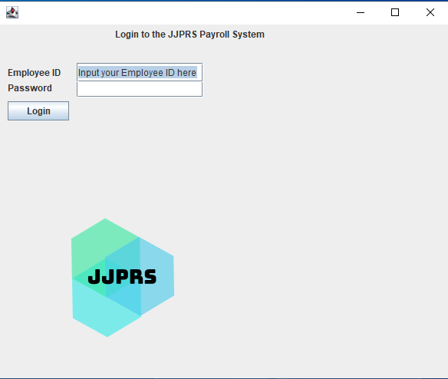

If you have an admin username and password you can add that to gain additional access.

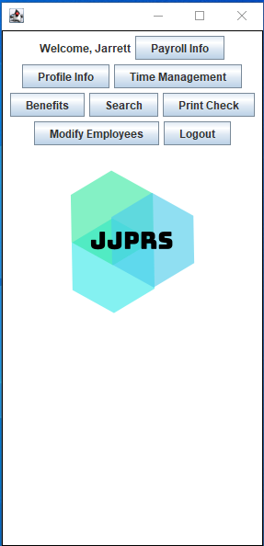

Step 2: Main Menu

Once you are logged in, you can click on various panels depending on your needs. Here is an example image of what to expect once logged in:

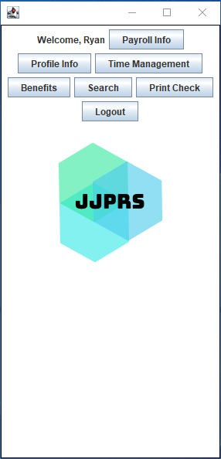

Step 3: Payroll Info

By clicking on the “Payroll Info” panel you can view your salary per year, your net pay, local tax deduction, federal tax deduction, your 401k deduction, health plan deduction, and your position title (part-time or full-time). Once you are done you can click “Return to dashboard” to return to the previous menu.

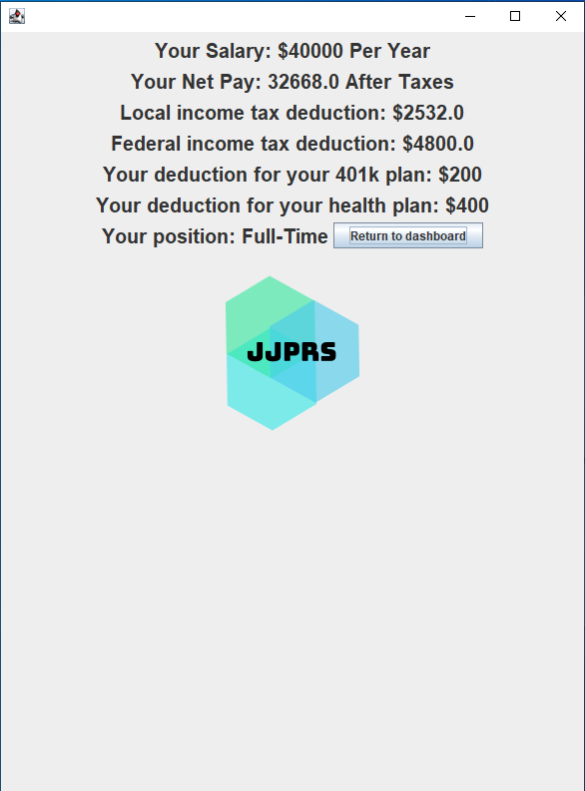

Step 4: Profile Info

Next, we can click on the “Profile Info” panel.

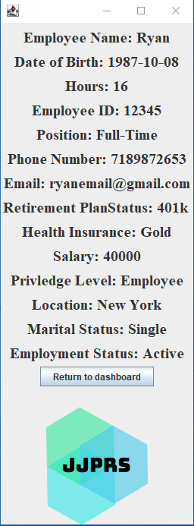

Profile Info will show all the user’s personal information. It will show their name, date of birth, hours, employee ID, position, phone number, email, retirement plan, health insurance plan, salary, privilege level, location, marital status, and employment status. Once done simply click “Return to dashboard.”

Step 5: Time Management

To add employee hours simply click the “Time Management” panel. Simply enter your hours and hit “Submit”. This will update to your current working hours in the database. Once done click “Return to dashboard.”

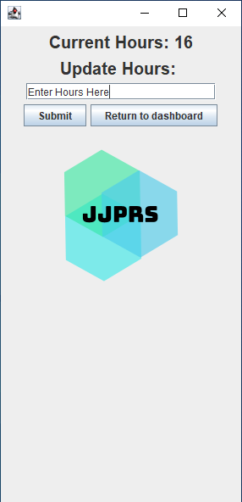

Step 6: Benefits

The “Benefits” panel will show all the benefits for an employee. It will show your sick leave days, dental insurance, life insurance, childcare, paid vacation days, personal leave days, and your health plan information. Once done click “Return to dashboard.”

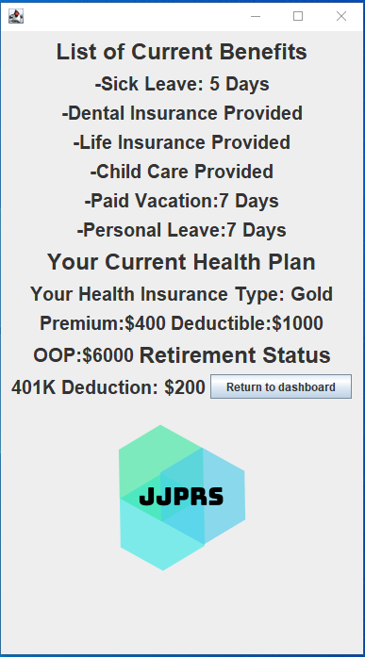

Step 7: Search

Our “Search” panel allows the user to search up other employees by their employee ID. Here is an example and picture of how it works:

In the text area you will enter the employee ID you would like to search.

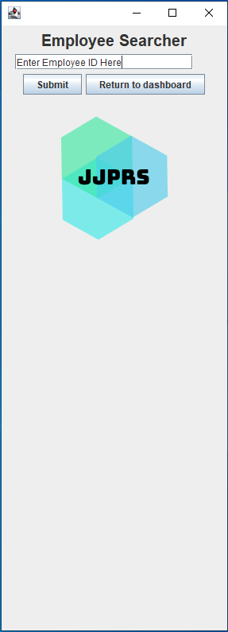 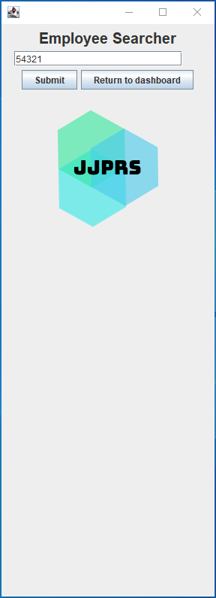

After you hit submit you will see some contact information on the employee you have searched.

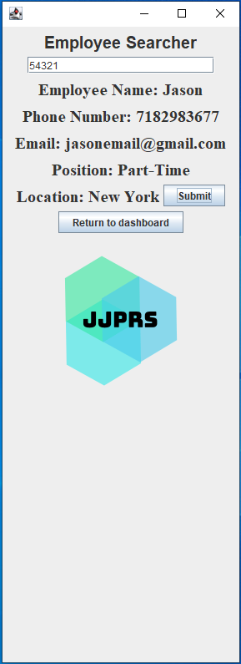

Step 8: Print Check

The last employee panel is the “Print Check” panel. After clicking this panel, a separate panel will pop up displaying the printed check. The newly opened panel will print out your employee information, tax information, deductions, gross pay, net pay. Once you are done you can simply close the print check panel.

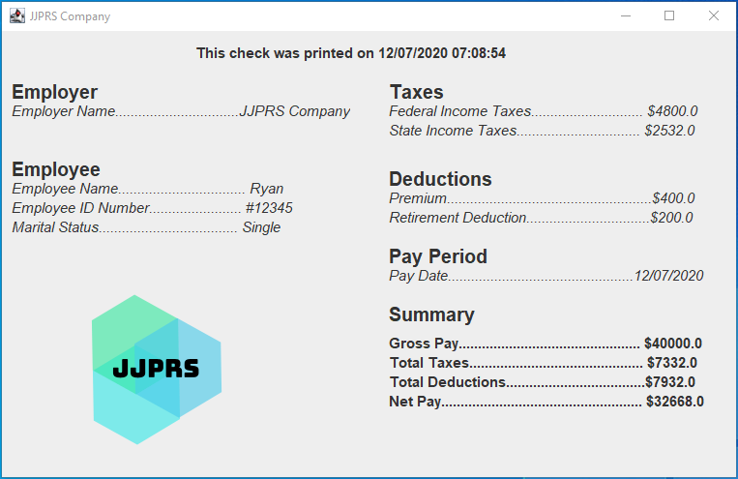

Step 9: Modify Employees (Admin)

Admin accounts also have additional access to the “Modify Employees” panel.

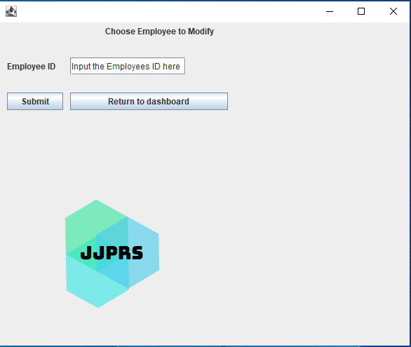

Once an admin is on this panel they can type in an employee ID they wish to modify.

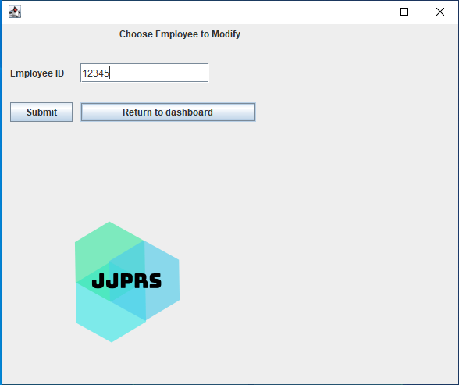

A new panel will pop up in which an admin can click the new changes they want to make to the chosen employee. Once they are done with the changes they can hit submit then “Return to Modify Employee” if they are complete.

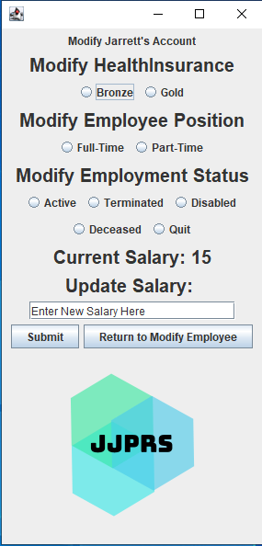

Step 10: Logout

Once you are done do not forget to click Logout!

1. Troubleshooting & Support

Q: I do not know my Username and/or Password.

A: Send an email to HR or tech support to reset your password. Your username and password are created by them and will be stored in your company’s database.

Q: My connection to the database is failing. What should I do?

A: Check with your company and see if there is a problem with their database connection. All user information will be within our customer’s databases.

Q: Why does the logging in take a few seconds?

A: This is a security feature in the system and is working as intended.

Q: Why is nothing happening when I search another employee’s name?

A: Try searching for an employee by their ID. We will add a feature to search by employee name in version 3.0.

Q: My application will not start.

A: Check if you have the latest version of java installed and check your internet connection.